Eagle & Child
Children’s menu

STARTERS:

Battered Goujons of fresh haddock with tartare sauce £3.00

Garlic Bread £1.75
With Mozzarella cheese £2.25
Home made soup of the day with bloomer bread £2.50

Mini Prawn Cocktail, brown bread & butter £3.75

MAIN COURSES:

Home Farm sausages with mash and garden peas £5.50

Home made 100% beef burger, served on a brioche bun £5.50
with tomato, lettuce & fries

Mini fish & chips served with mushy peas or beans £5.50

Breaded strips of chicken fillets with fries & beans £5.50

DESSERTS:

Warm chocolate brownie, chocolate sauce, vanilla ice cream £3.50

Sticky toffee pudding, toffee sauce, vanilla ice cream £3.50

2 scoops of Walling’s Farm ice cream £3.50

Strawberry Ice Cream Sundae £3.50

Please make sure our staff are aware if you have any food allergies,
when taking your order
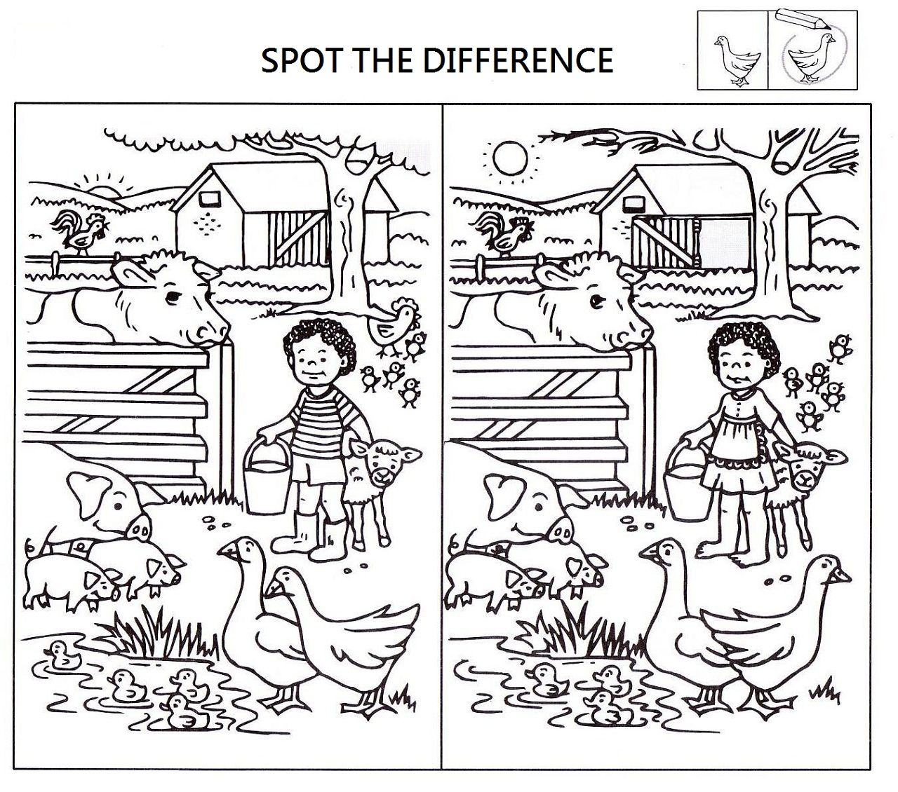

There are 8 Differences to find!

